IFIC
Architecture and Execution Flow Version 1.0

Revision History
Rev | Date | Description of Change | By
1.0 | 2025-11-04 | Initial version of document | Darryl Poworoznyk

Table of Contents
Contents
Revision History 1
Table of Contents 2
Executive Summary 3
System Overview 4
Purpose 4
Major Functions 4
High-Level Architecture 5
External Systems 5
IFIC Core Layers 5
Architecture and Execution flow 6
Overview 6
Execution Flow 8
Initialization 8
File detection 8

Executive Summary

The IRRS/FHIR Intermediary Component (IFIC) is a middleware application developed for VitalHub to enable seamless, secure, and standards-compliant data exchange between Clarity Long-Term Care Facility (LTCF) systems and the Canadian Institute for Health Information (CIHI) through the Integrated Resident Reporting System (IRRS).
IFIC automates the transformation of LTCF assessment data from flat file format into FHIR-compliant XML bundles, performs OAuth2 authentication against CIHI’s secure API gateway, and manages submission responses, database updates, and error handling.
The solution was designed under the CIHI Vendor Certification Framework (2024–2025) and fully conforms to:
- IRRS Reference Manual (FHIR R4 implementation)
- CIHI API Security Guide v1.4 (JWT Client Credentials)

IFIC provides a reliable, auditable, and modular integration layer between VitalHub’s Clarity and the CIHI IRRS submission endpoints.

System Overview

Purpose
IFIC bridges the internal Clarity database and CIHI’s IRRS FHIR interface by:
- Parsing Clarity’s exported LTCF assessment files.
- Mapping each data element to the corresponding FHIR field.
- Constructing Patient, Encounter, and QuestionnaireResponse resources.
- Bundling these resources into a valid FHIR transaction payload.
- Submitting securely via OAuth2 (JWT bearer token).
- Writing submission results and FHIR identifiers back into Clarity.

Major Functions
- File ingestion and validation
- Dynamic field mapping using Excel mapping sheets
- XML construction using strongly typed builders
- OAuth2 authentication and token caching
- FHIR bundle submission and response parsing
- Clarity database update and result tracking
- Automatic folder routing for Queued / Processed / Errored files

High-Level Architecture

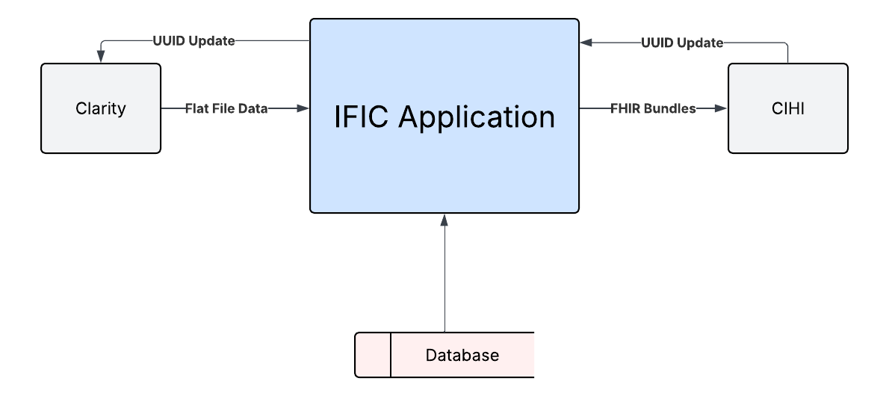
Figure 1.1 – IFIC Component Diagram

External Systems
- Clarity LTCF: Generates the .dat files for processing and receives the write-backs from IFIC containing the important information from the CIHI response.
- CIHI IRRS API: Receives authenticated FHIR compliant submissions and processes them.

IFIC Core Layers
- Runner Layer: Program.cs, ClarityLTCFUpdateService.cs
- Parsing Layer: FlatFileParser.cs, ParsedFlatFile.cs
- Transformation Layer: BundleXmlBuilder.cs, PatientXmlBuilder.cs, EncounterXmlBuilder.cs, QuestionnaireResponseBuilder.cs, EntryPointResolver.cs
- Integration Layer: AuthManager.cs, IRRSApiClient.cs
- Persistence Layer: ClarityClient.cs, ClarityClientOptions.cs, ElementMapping.cs
- Metadata Layer: AdminMetadata.cs, AdminMetadataKeys.cs

Architecture and Execution flow

Overview
IFIC (Intermediary FHIR Integration Component) is structured as a multi-layered .NET application designed for modularity, maintainability, and interoperability with VitalHub’s LTCF (Long-Term Care Facility) system Clarity.
Each layer isolates a distinct responsibility—parsing, transformation, API integration, and persistence—to simplify maintenance, facilitate testing, and ensure fault tolerance. The system ingests structured flat files exported from Clarity LTCF, partially parses them into typed model objects and/or key valued pairs, transforms those into FHIR-compliant XML or JSON bundles, authenticates with CIHI’s OAuth2 gateway, submits data to the IRRS FHIR endpoint, and writes all submission results back to the local Clarity database.
- The File Ingestion Layer monitors a configured directory for queued flat files and initializes each processing job.
- The Parsing Layer (FlatFileParser) tokenizes sectioned data ([PATIENT], [ENCOUNTER], [SECTION A–N]) into in-memory models such as ParsedFlatFile.
- The Transformation Layer (BundleXmlBuilder, PatientXmlBuilder, EncounterXmlBuilder, QuestionnaireResponseBuilder) maps parsed values into fully compliant FHIR resources using field mapping tables.
- The Integration Layer (AuthManager, IRRSApiClient, CihiResponseParser) handles authentication, submission, and response parsing through CIHI’s REST API.
- The Persistence Layer (ClarityClient) commits results—including generated FHIR IDs, submission timestamps, and errors—back into the Clarity SQL database for audit and retry control.
This layered structure ensures loose coupling between components, enabling developers to test or extend individual functions (for example, supporting JSON payloads or new FHIR resource versions) without disrupting the rest of the system.

Figure 1.1 – IFIC Component Diagram
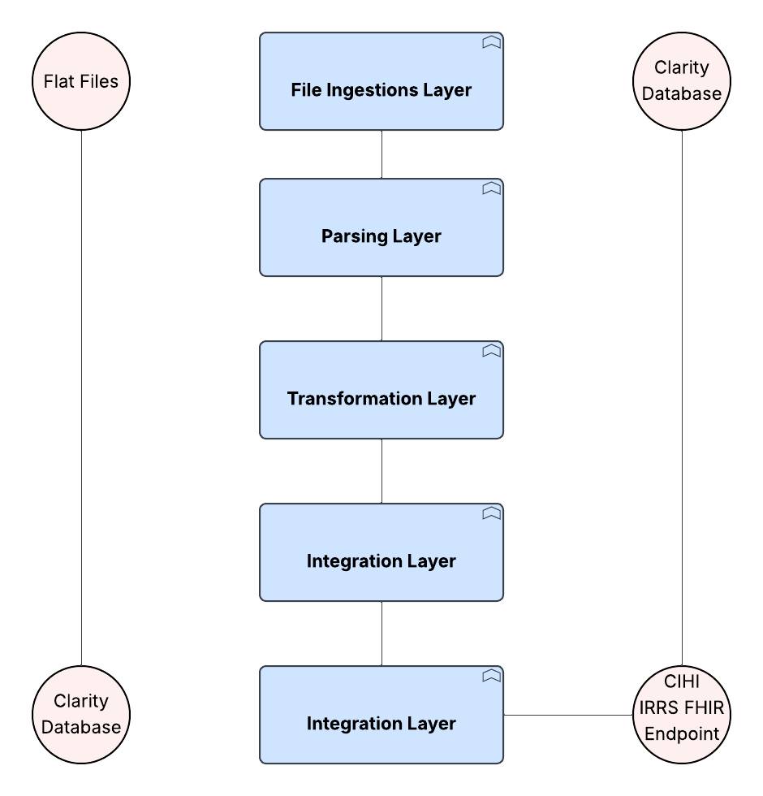
Figure 2.1 – IFIC Layered Architecture

Execution Flow
The IFIC (Intermediary FHIR Integration Component) application executes a structured, stepwise workflow that automates the transformation and transmission of LTCF (Long-Term Care Facility) assessment data from the Clarity system to the CIHI IRRS FHIR API. Each phase of execution is designed with clear separation of concerns to ensure traceability, maintainability, and recoverability.

Initialization
At startup, the Program.cs file initializes the application environment. Configuration settings are read from appsettings.json, which defines:
- TransmitRoot directory paths (Queued, Processed, Errored)
- Database connection string for the LTCF test or production instance
- FHIR base URL for CIHI IRRS endpoint communication
- Key and certificate paths used for OAuth2 token generation
Before proceeding, the system ensures that all logging and working directories exist, creating them dynamically if missing. This guarantees that all runtime events and results are properly recorded for audit and debugging.

File detection
Once initialized, IFIC begins scanning the Queued directory under the TransmitRoot location for pending data transmission files (typically .dat format).
For each discovered file:
- An instance of ClarityLTCFUpdateService is created to manage the end-to-end processing.
- The file path is passed to the FlatFileParser component for parsing.
This modular design allows multiple queued files to be processed independently in sequence or via future concurrency extensions. If two queued files for one patient, encounter or assessment are in the same run of IFIC the system saves the id from the created resource to use in the next flat file submission.

